# Putting an XPO in to NAXT Production

## Before Tasks

* XPO should be approved for prod by CAT Business Owner (Andy Johnson)
* Alert banner on Fetch on when the outage will be (has to be out of hours).
* If towards month end send a courtesy email to anyone you think might be working out of hours in NAXT (Victoria Sergel?)

## Blocking NAXT logins

Mgmt.

Go to \\cclads01\NETLOGON\NAXTConf

## Stopping AOS’s

[Stopping NAXT AOSs Services.docx](https://goughgroupltd-my.sharepoint.com/:w:/g/personal/blair_doherty_goughgroup_co_nz/ERtG64zsyKRHu3vvmIDSUs0BWo3huof8J6IMEFD0-0002w?e=xZMQxC)

## Importing XPO

1. Start Test CU7
2. Ctrl+D to open the AOT menu

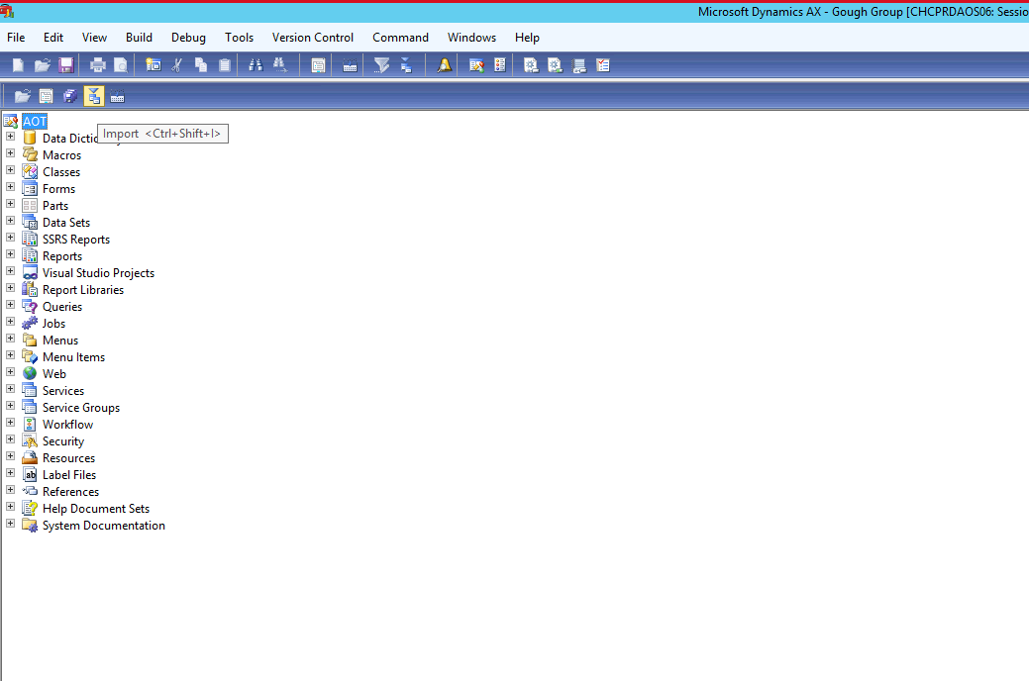

1. Click Import (see screenshot above)

(Normally the Location of XPO’s)

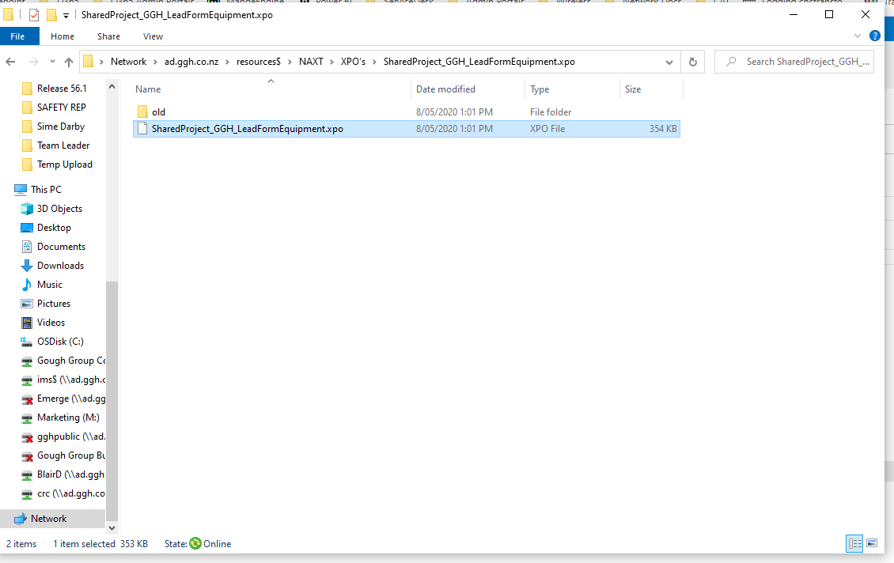

1. Browse and find the XPO you want to import
2. Click Show details
3. UnTick Projects
4. Click Ok
5. If prompted that already exsists click “Yes to all”

Can be very quick to import other times can take a few minutes.

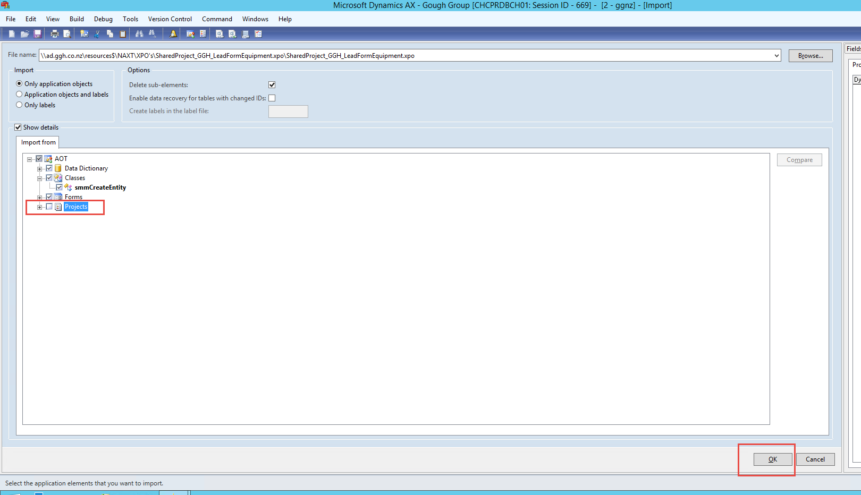

1. Once done close out of the AOT and go to System Administration -> Periodic
2. Then run “Compile into .NET Framework CIL” (can take 5 – 20 mins)

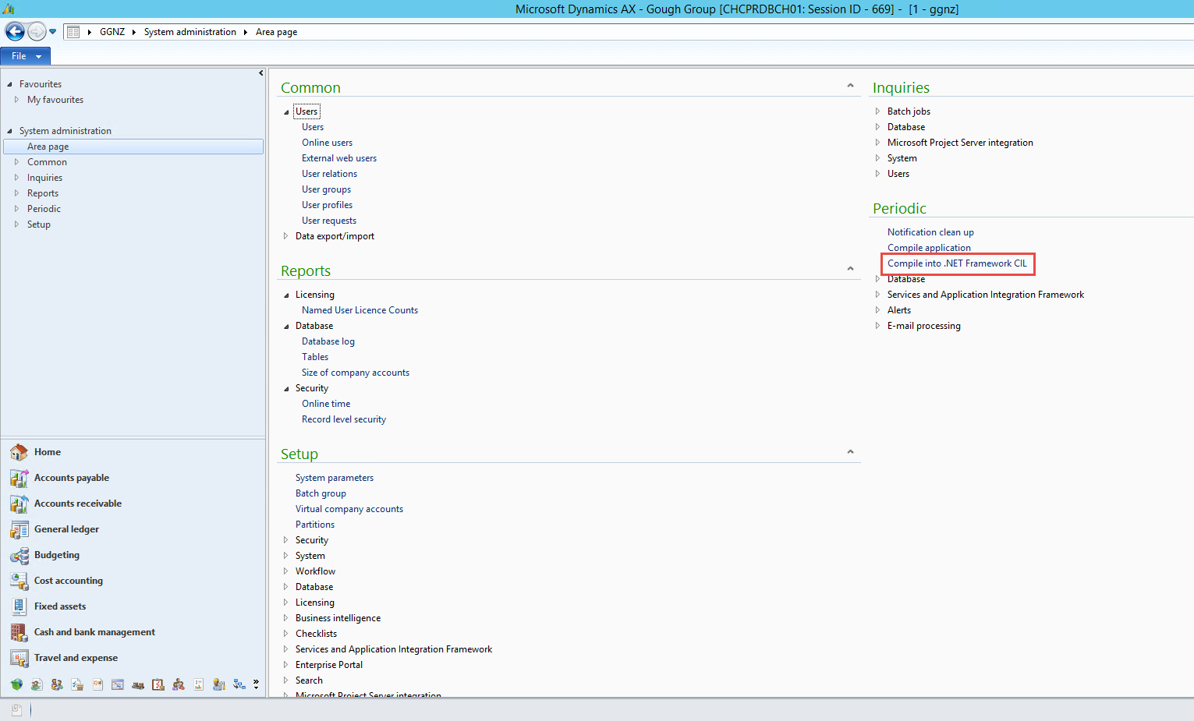

1. Once run turn the servers back on and make sure you can open it through citrix and go to a couple of different areas.